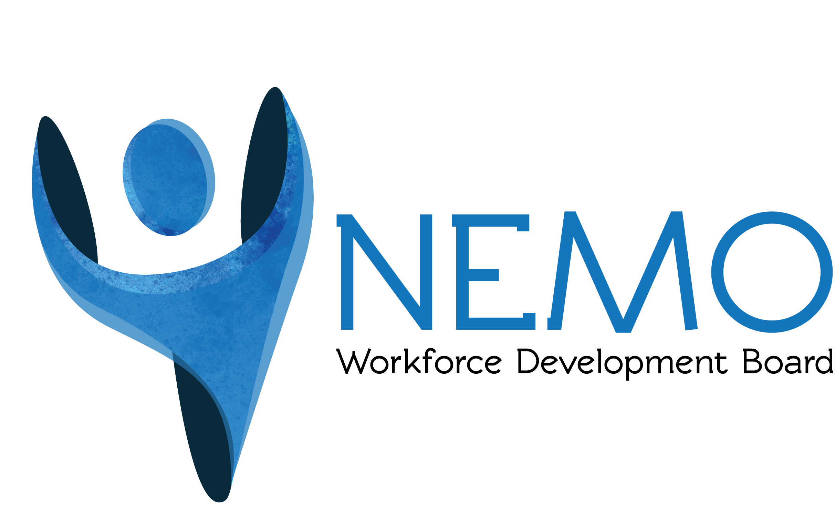 NEMO WORKFORCE DEVELOPMENT BOARD 

111 East Monroe • Paris, Missouri 65275 • Tel: 660.327.5125 • Fax: 660.327.5128 • TTY: Dial 7-1-1
www.nemowib.org

CREDIT CARD POLICY
The NEMO Workforce Development Board will have one credit card and will be used for the purposes of purchasing office supplies, expenses incurred for business travel, and online purchases, registrations, and membership dues. The credit card has a credit limit of $5,001.00. All charges will be at the discretion of the Executive Director or the Executive Committee.

The Operations/Program Coordinator is responsible for retaining the credit card, tracking credit card balances and reconciling the statement each month before approval by the Executive Director and submitted to the Fiscal Officer for payment. Employees shall submit an invoice or other proof of purchase to the Operations/Program Coordinator at the time of purchase/use. The NEMO WDB utilizes open accounts and direct billing where available; therefore, the credit card should be used as a last resort when billing cannot be established.

WDB employees understand:
- The credit card is company property and when they use the credit card, they are making a financial commitment on behalf of the company.
- The credit card is to be used for business purposes only and any personal, unauthorized, or illegal charges or misuse will result in disciplinary action up to and including termination of employment.
- Purchase of gasoline or alcohol are prohibited.
- An exception will be made if, while on business, an employee incurs a joint expense for themselves as well as their spouse, the employee will reimburse the cost of their spouses’ expense on the next travel expense claim or within 30 days whichever occurs first.
- The employee is responsible to reconcile his/her expenses and timely submit an expense report along with all supporting documentation/receipts. If the employee cannot produce the supporting documentation/receipts, it will be at the Executive Director’s and/or the WDB Executive Committee’s discretion to determine whether or not the charges are allowable and payable by the WDB. The employee is responsible to make a concerted effort to obtain the documentation. If the charges are not approved without supporting documentation, the expense incurred will be the employee’s responsibility to repay on the next travel expense claim or within 30 days whichever occurs first.
- The WDB may review and investigate use of this credit card and there are no expectations of privacy concerning any charges incurred.
- The employee will repay any personal, unauthorized, or illegal charges made by the employee, including administrative fees and/or finance charges assessed in connection with such charges. The WDB may take appropriate legal action to collect the monies owed. If the WDB is required to take legal action to collect monies, the employee agrees to pay the WDB expenses, including attorney’s fees incurred in the collection efforts. Repayment will be completed through payroll deduction as long as the deductions do not take the employee’s wages below the required minimum hourly wage rate. In that case, payment will be allocated as needed.

I have read the above Credit Card Policy and understand my responsibilities as an employee of the NEMO Workforce Development Board. I also understand the consequences should I violate the policy.

__________________________________ __________________
Employee Signature Date

