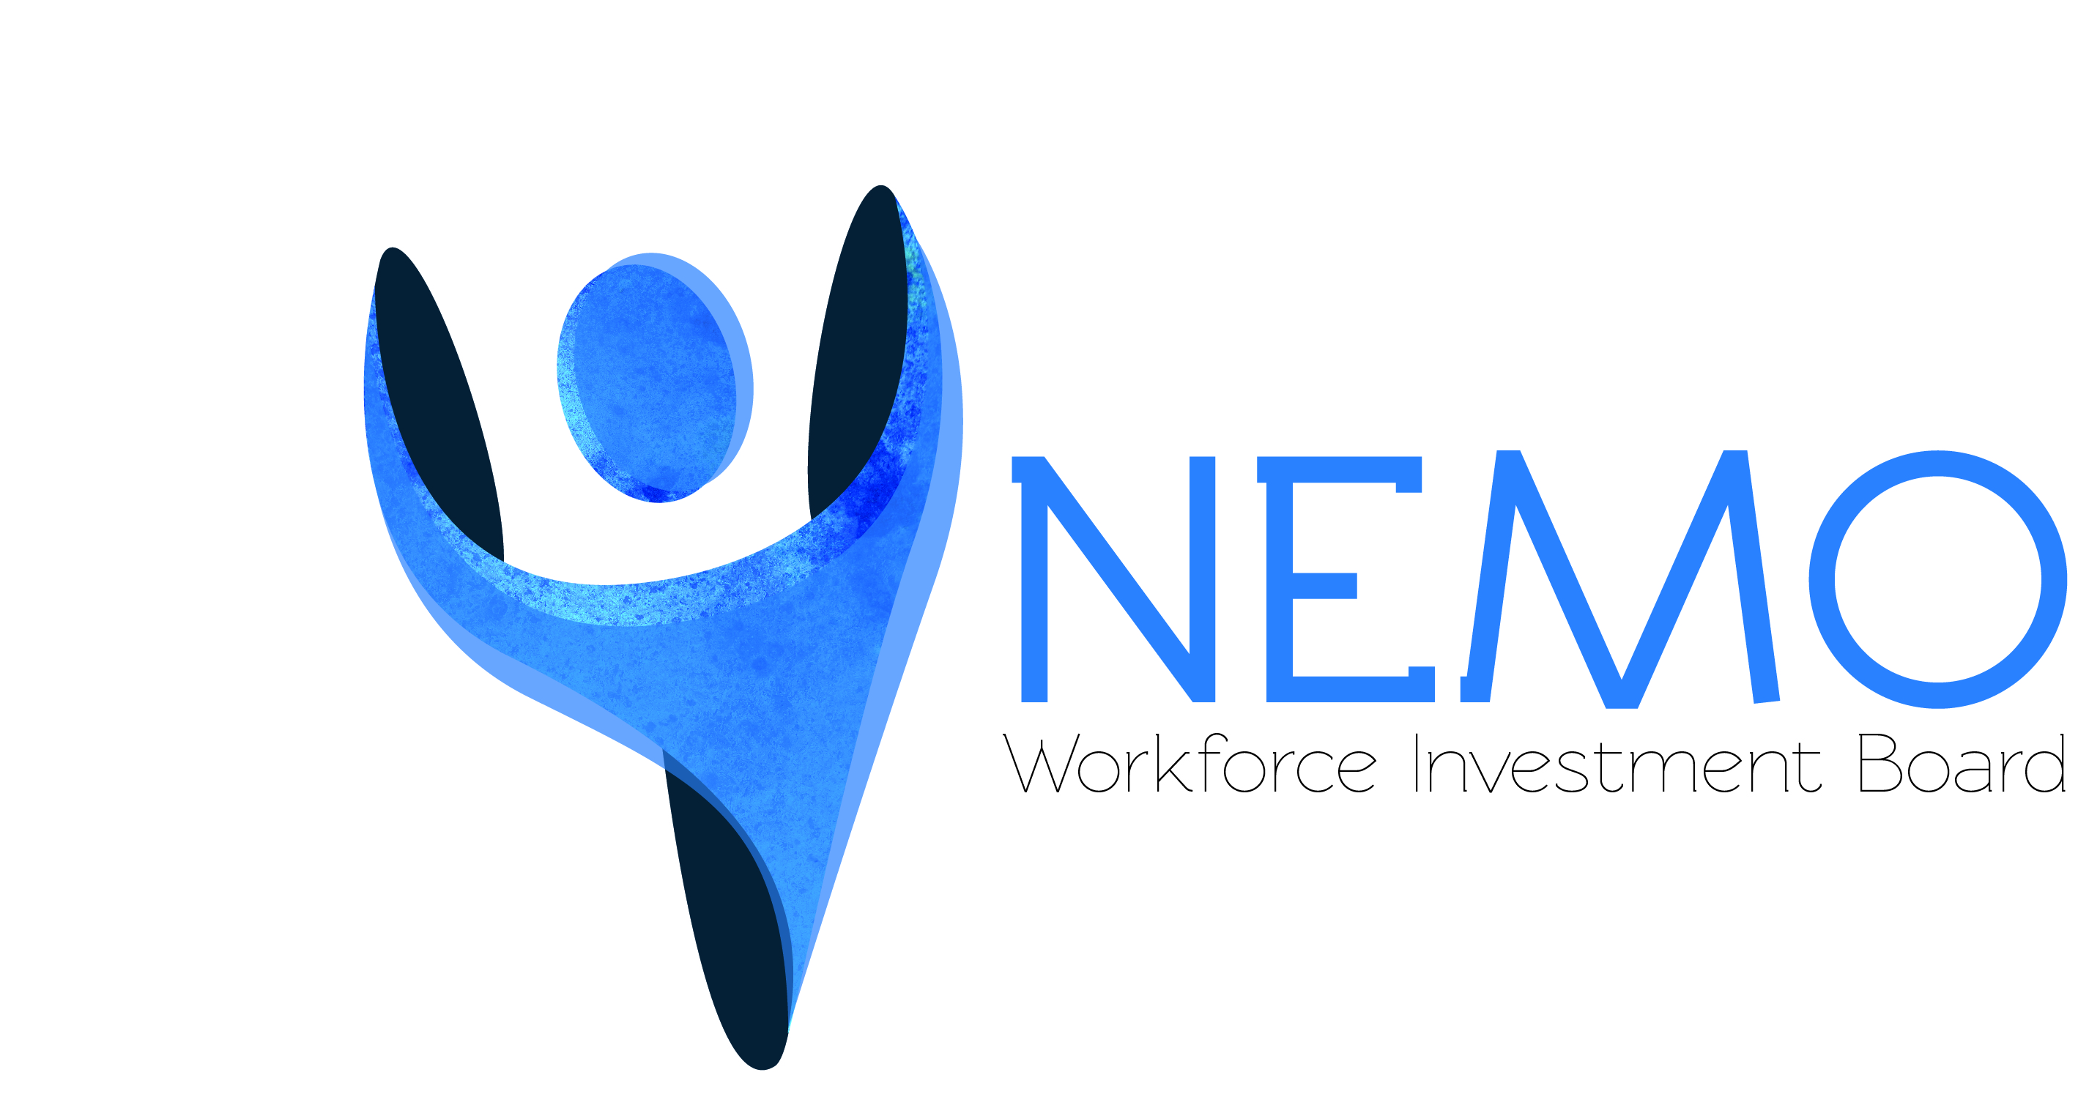

NEMO Workforce Development Board, Inc.
WIOA YOUTH INCENTIVE FORM
(Revised 4/15/2019)

Participant Name: ______________________________________________________

Address: ______________________________________________________

City, State, Zip ______________________________________________________

✓ | Incentive | Required Documentation | Amount
 | Attainment of GED | - Allowable documentation includes: Transcripts, certificates, diploma, letter from school system.  - Documentation must be placed in file before payment can be made.  - Documentation must include attainment date. | $50.00
 | Attainment of High School Diploma | - Allowable documentation includes: Transcripts,  certificates, diploma, letter from school system.  - Documentation must be placed in file before payment can be made.  - Documentation must include attainment date. | $100.00
 | Attainment of Post-Secondary Certificate | - Allowable documentation includes: Transcripts, certificates, diploma, valid license, letter from training agency | $50.00
 | Completion of WorkKeys test and attainment of NCRC - Bronze Level | - Allowable documentation includes: printout of scores/level achieved and scores entered in toolbox, copy of NCRC certificate.  - Documentation must be placed in file before  payment can be made.  - Documentation must include attainment date. | $50.00
 | Completion of WorkKeys test and attainment of NCRC - Silver Level | - Allowable documentation includes: printout of scores/level achieved and scores entered in toolbox, copy of NCRC certificate.  - Documentation must be placed in file before  payment can be made.  - Documentation must include attainment date. | $100.00
 | Completion of WorkKeys test and attainment of NCRC - Gold Level | - Allowable documentation includes: printout of scores/level achieved and scores entered in toolbox, copy of NCRC certificate.  - Documentation must be placed in file before  payment can be made.  - Documentation must include attainment date. | $125.00
 | Completion of WorkKeys test and attainment of NCRC - Platinum Level | - Allowable documentation includes: printout of scores/level achieved and scores entered in toolbox, copy of NCRC certificate.  - Documentation must be placed in file before  payment can be made.  - Documentation must include attainment date. | $150.00
 | Completion of Post TABE test and increasing scores by at least one EFL on at least one area | - Youth must be Out-of-School youth as defined in TEGL 17-05.  - Must complete all post tests in which a deficiency is being measured.  - Must have scored an 8.9 or below in reading, language or math full battery TABE pre-test.  - Allowable documentation includes: TABE test, TABE on-line testing score sheet, TABE score sheet, verification of scores in written form from GED/AEL instructor  - Documentation must be maintained in file before payment can be made | $50.00
 | Measurable Skills Gain indicator measuring interim progress of participant enrolled in education or training services for a specified reporting period as defined in DWD Issuance 19-2017 (Numbers 3-5) | 󠇞 Documentation of completing a sufficient number of credit hours to demonstrate that the participant is meeting the State’s academic standards.  󠇞 A report of satisfactory, or better, progress toward established milestones. Can include completed stages of On-the-Job Training (OJT), the completion of benchmarks or milestones during an apprenticeship program, or a report from an employer or training provider that is providing training. Documentation from employer/training provider required.  󠇞 Successful passage of a knowledge-based or skill-based exam that is required for a particular occupation or that demonstrates progress in attaining technical or occupational skills. (CDL, CNA, etc.) Documentation proving attainment is required. | $50.00
 | Obtaining Unsubsidized Employment and retaining the job for 4 months | - Allowable documentation includes: Paycheck stubs and proof of employment at 4 months  - Documentation must be placed in file before  payment can be made.  - Documentation must include attainment date. | 100.00

******************************************************************************

I certify that the above goal(s) were met and I am eligible to receive this incentive.

___________________________________________________ ___________________________________
Participant Signature Date

___________________________________________________ ___________________________________
WIOA Case Manager Date

___________________________________________________ ___________________________________
WIOA Director/Functional Leader Date

Rev 4/15/2019

The NEMO Workforce Development Board is an equal opportunity employer/program. Auxiliary aids and services are available upon request to individuals with disabilities. Missouri TTY Users may dial 7-1-1.

